Skip to content

Table of Contents
- Palanquin Bearers – Summary , Analysis and Questions
  - Palanquin Bearers| Summary
    - Analysis of Palanquin Bearers
    - Questions of Palanquin Bearers
      - Palanquin Bearers | Literary Devices

Palanquin Bearers – Summary , Analysis and Questions
About The Poet: Sarojini Naidu was born on February 13, 1879, in Hyderabad. She belonged to a renowned family. Her father Dr Aghornath Chattopadyaya was a scientist and her mother was a Bengali poet, Mrs Varasundari. Sarojini Devi inherited her incredible qualities both from her mother and her father. She studied at London and Cambridge. She was an outstanding poet and fluent in English. From the early years of her life, she began writing poetry.

Sarojini Naidu
She was a distinguished patriot, politician, orator, administrator and poet. She became the first woman Chairman of the National Congress of India. She also participated actively in Gandhi’s Satyagraha programmes. She was also named Utter Pradesh’s Governor.

OUR LATEST VIDEOS
Daffodils Critical Appreciation In ...
Play
Unmute
Loaded: 12.24%
Remaining Time -1:16
Fullscreen
- Now Playing
Characteristics of Language
- 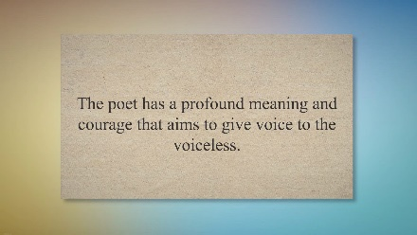
UP NEXTSpeak Up By Faiz Ahmad Faiz- Summary And Question Answers Class 10th (Tulip Series 10th)
10:33
- 
Characteristics of Language || #language #languagecharacterics #languagevidio
1:21
- 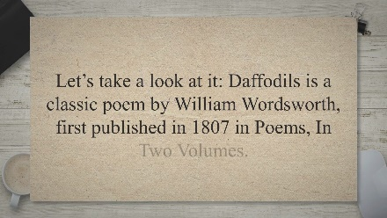
Daffodils Critical Appreciation In 500 Words
7:08
- 
Prayer By G. A. Mehjoor ( Tulip Series 10th)
7:01
- 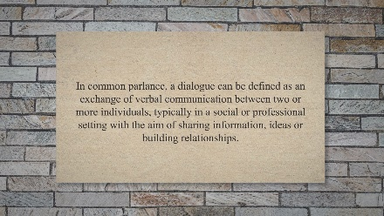
Dialogue Writing in English - Rules And Do's And Dont's || Class 8th, 9th And 10th
6:25
- 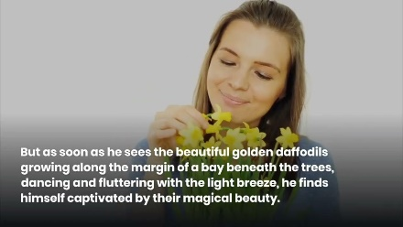
Daffodils by William Wordsworth || Summary in English || Class 12
2:42
- 
Polythene - A Disaster || Short Summary
1:02
- 
Spring in Kashmir Essay || #spring #kashmir #essay
1:59
- 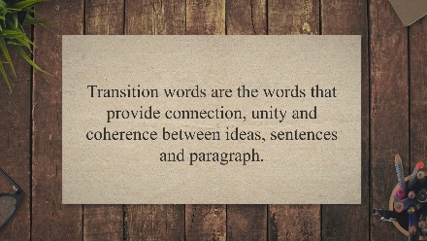
Useful Transition Words And Phrases For Writing Essays
20:40
- 
Polythene: A Disaster summary
0:57
- 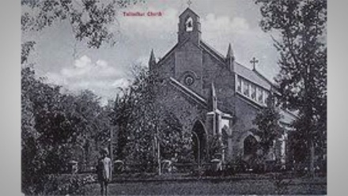
In Passion’s Shadow By Mohan Rakesh
7:36
- 
Prayer For Strength By Rabindranath Tagore Summary And Questions Answers
2:38
- 
The Road Not Taken || Summary in English || Class 9th
1:25
- 
Characteristics of Metaphysical Poets - Smart English Notes
1:04
Daffodils by William Wordsworth || Summary in English || Class 12
2:42
- 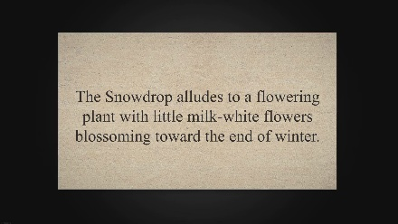
Analysis of Snowdrop Poem by Ted Hughes
3:16
Spring in Kashmir Essay || #spring #kashmir #essay
1:59
- 
Snowdrop By Ted Hughes - Summary, Analysis And Question Answers
8:27
- 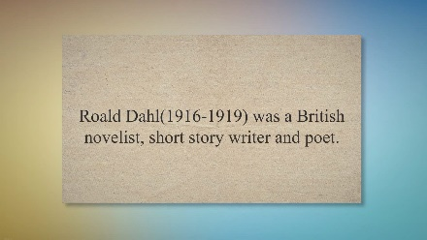
Lamb To The Slaughter - Summary And Questions And Answers
12:01
Characteristics of Language || #language #languagecharacterics #languagevidio
1:21
Polythene - A Disaster || Short Summary
1:02
The Road Not Taken || Summary in English || Class 9th
1:25
- 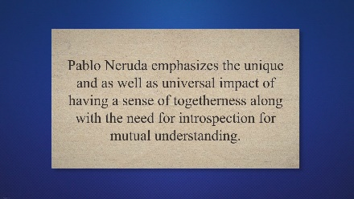
Keeping Quiet - Explanation, Literary Devices And Solved Questions ( Class 12 Flamingo English| JK BOSE
4:21

Daffodils Critical Appreciation In 500 Words
His enthusiasm for poetry was due to his lack of interest in mathematics. She penned down her first enlivened poetry in the algebra book and subsequently enthused by this ” Lady of the Lake, ” a poem composed of 1300 lines in length. Her well-known books are The Bird of Time, The Broken Wing and The Golden Threshold. Because of her great contribution to poetry, which contained English words but an Indian soul, she was given the title of ‘ Nightingale of India. ‘ Her English poetry was published in ” The Dawn Feather ” and ” Flute Sceptred. ”

Palanquin Bearers| Summary

The poem ‘Palanquin Bearers‘ can be well understood in the Indian context. In most parts of India, the custom was to bring a bride to the house of her husband in a palanquin by the palanquin bearers. The palanquin bearers thought it was a privilege to bring the royal princess to the home of their groom. The royal family’s bridegroom would most of the time go with her bride on horseback.
The palanquin bearers are pleased to bring a royal bride to the house of her husband in the poem. As they walk, they feel that she is as delicate as a flower that swings as they walk in their song. She skims smoothly as the birds glide on the wild river.
The palanquin bearers are pleased to bring a royal bride to the house of their husband in the poem. As they walk, they feel that she is as delicate as a flower that swings as they walk in their song. She skims smoothly as the birds glide on the froth of river.
“She skims like a bird on the form of a stream” is the description given by the bearers to suggest how tender and delicate the bride is.
She looks so graceful when she sits in the palanquin and the view is so nice to see. One remembers the sight of a bird sitting in a stream on the ripples. Her laughter shows she’s happy about the new life she’s leading.
The second paragraph tells us that the palanquin bearers are so careful when they carry her as if she were a pearl on a string. She’s very valuable to them. She is compared with a star that sparks and springs like a light beam. She seems to fall like a tear from the bride’s eyes. Her tears show that she is miserable because of her separation from her parents and other relatives. The palanquin bearers carry her softly and smoothly to the extent possible so that she would not feel the journey exhausting. They carry her as if she was an invaluable jewel held by her husband.

READ ALSO: What Were They Like? summary, Analysis, Form and Languages and Questions

This shows that they have gained a certain respect for her and delicately treat her and her emotions. The poet emphasizes the emotional situation of the bride and her mixed emotions continually. Especially the last line of both stanzas. “We bear her along like a pearl on a string.” This represents the real palanquin with the strings as the sticks and the pearl as the string. This also shows that the palanquin carriers try their best to prevent the royal bride from being emotionally hurt.

Analysis of Palanquin Bearers

‘Palanquin-Bearers’ is a short poem developed in two stanzas of six lines each and has the rhyme scheme as aa, bb, cc. The poem expresses the joy and pride of palanquin bearers in carrying a bride to her husband’s house with sensing a song in rhythmic harmony and footsteps. The bearer carries the bride with care and considers her as if she is like dew or a tear drop.
‘Palanquin-Bearers’ begins with a typical traditional picture of palanquin bearers which deals with common sight of the whole India during the 19th and early 20th century. The poem is in romantic mood. The theme and imagery are fused artistically, which leads poem to a universal appeal. The song sung by the palanquin bearers, narrate the basic human emotions and the mind of the bride is controlled by that song. This poem reveals the Indian reality through folk characters. Palanquin Bearers are depicted as a part of Feudal system of Indian life and they glorify their tradition. The poem rightly brings out one of the facets of the Indian life-the feudal system in India and the Palanquin Bearers as the most natural part of this system. The Palanquin Bearers was one of the sanctioned customs of the contemporary Indian life. Naidu glorifies this custom in a view to reassert the sense of Indian ness and thereby, to develop pride among Indians about the rich heritage of folk culture which was vanishing due to the colonization. The folk characters in the poem glorify their tradition without the least reference to their oppression under this system; Sarojini Naidu composes a folk song out of their reality, in terms which would please the gentry.
Naidu depicts this common scene in Hyderabad as representing the traditional Indian life. She has a high idealized sense for this life and is least concerned about the toil, sweet and oppression of the Palanquin Bearers. Naidu glorifies this custom is view to reassert the sense of Indianness.
The whole setting of the poem is romantic. We observe the Palanquin Bearers to her husband’s house. The Palanquin Bearers usually sang song in rhythmic harmony with their footsteps. A soft music leaps up in the air as the Palanquin Bearers bear the blooming beauty along. The idealized sense of duty and responsibility of the Palanquin Bearers reveals here as:-
Lightly, o lightly, we bear her along,
She always likes a flower in wing of our song She skims like bird on the foam of streams
She floats like laugh from the lips of a dream
Gaily, o gaily we glide and we sing,
We bear her along like a pearl on a string.
They are shown in idealized postures, in effect, celebrating and glorifying their own oppression. Naidu is very much interested in this age-old custom which is part of Indian life and culture, where she locates Indianess with collective identity of India.
The rhythmic movement of the Palanquin Bearers footsteps corresponds with the heartbeats of the bride inside. Excited and instigated, she swings in the dreams of love “like a flower in the wind” in the song of the song of the Palanquin Bearers. The bride is leaving her familiar parental house to join her love in a new home; she is in strange emotional predicament. There is joy and excitement but, also melancholy and anxiety. The poem creates Indian women’s delicate world which is marked with love and excitement as well as pain and curiosity. The Palanquin Bearers, the song and the springy movement all are skillfully fused to create a dream like atmosphere.
In the second stanza the poem moves from the dreamy surfaces of life to its stark realities. From a passive role of a daughter, the bride moves on to the active and responsible role of a wife. The poem beautifully expresses the mixed feeling of an Indian bride who experiences both the pangs of separation as well as hops for new life and happiness. The imager are both abstract and concrete and at the same time appealing.
‘Palanquin Bearers’ is her best known poem in an intricate metrical composition, each line having four feet with three anapests, followed by a shorter iambic foot.
According to Dastoor (1961:23), the poem is “a fair specimen of the true folk song.” He further observes that “it recalls a common experience in the India of a century ago, and the song of Palanquin Bearers expresses in its movement the mutt led mumblings which dictated the rhythm of their march through the streets”(23)

Questions of Palanquin Bearers
Q.No.1 What are the feelings of the palanquin bearers as they carry the princess inside the palanquin?
Answer: The palanquin bearers are delighted as they are carrying a royal bride to her in-laws. As they walk, they feel that she is as delicate like a flower who sways at their song. The palanquin bearers are so careful when they carry her as if she were a pearl on a string. This showcases that they have gained some respect towards her and actually treat her and her emotion delicately.
Q.No. 2 “Lightly, O lightly we bear her along; she sways like a flower in the wind of our song.” What are these opening lines suggestive of? Do you think the palanquin bearers are sensitive to the presence of the bride?
Answer: These lines suggest that the bride inside the palanquin is very delicate and light. She is invaluable and also it is the most sacred and auspicious occasion for her.
The palanquin bearers are very sensitive to the presence of the bride as they handle her like a very precious jewel. They are so careful when they carry her as if she were a pearl on a string.

READ ALSO: Eid-ul-Fitr Mubarak Poems by Chat GPT

Q. No.3 What is the rhyme scheme of the poem? Pick out the pairs of rhyming words in the poem.
Answer: The rhyme scheme of the poem is aa, bb, cc
The rhyming words are along – song, stream – dream, sing – string, tide – bride

Palanquin Bearers | Literary Devices
Q.No. 4. In line 4 the poet says, ‘She floats like a laugh from the lips of a dream’ and in line 10 she writes, ‘She falls like a tear from the eyes of a bride.’ Do you think that the poet has deliberately used the device of contrast? Why has she done so?
Answer: The contradiction is when the poet describes the bride as “she floats like a laugh” and then she writes “she falls like a tear”. It is deliberate because the bride is in tears at her separation from her family. But she smiles because she is happy over going to be united with the love of her life and start a fresh and exciting life.
Q.No.5. Simile: A figure of speech used to compare the qualities of two objects or things using
words such as ‘like’ or ‘as’. For example
a. The poet compares the bride to a flower.
b.She hangs like a star in the dew of a song.
The poem is full of similes. Pick out all the similes used by the poet in the poem.
Answer: The poet has used various similes in the poem as given here as under:
1. She sways like a flower in the wind of our song;
2. She skims like a bird on the form of a stream,
3. She floats like a laugh from the lips of a dream.
4. We bear her along like a pearl on a string
5. She hangs like a star in the dew of our song;
6. She springs like a beam on the brow of the tide,
7. She falls like a tear from the eyes of a bride,
Q.No.6 Refrain: poets often use the device of the refrain. The refrain is a line or a part of a line or a group of lines repeated in the course of a poem. Did you notice that some words, lines/parts of lines are repeated in the poem?
Pick out these words or lines that are repeated. What effect does such repetition create in the poem?
Answer: The lines and words that are repeated in the poem are :
i. Lightly, O lightly we bear her alone.
ii. We bear her along like a pearl on a string.
iii) Softly O Softly
iv) Gaily O gaily
The refrain gives us the impression of a constant and balanced movement of the palanquin. It also adds in the rhythm of the poem.
Moreover, it bestows music to the song of palanquin bearers.
Q.No.7 You have studied in the last poem about images. Read the poem and complete the following table by matching lines from the poem with the related images conveyed by them.The line from the poem Image conveyed
Answer:
Skims like a bird = gliding movement of a bird flying over a stream
Sways like a flower = movement of a flower moving from side to side due to breeze
Floats like a laugh = laughter on the lips of a person during a dream
Hangs like a star = Be calm and heads down like a star over
Springs like a beam = sparkle like a ray of light
Falls like a tear = dropping of tears from bride’s eyes at the time of marriage
Post Tags:#Questions Answers and Analysis of Palanquin Bearers Class 9th JK BOSE

Post navigation

PREVIOUS
Summary and Questions of On Killing a Tree

NEXT
Questions Answers and Summary of An Evening Wet With Rain

Similar Posts

Love Bade Me Welcome by George Herbert – Summary and Questions
Bysmartenglishnotes08/10/2020

Rice by Chemmanam Chacko – Summary, Solved Questions & Notes
Bysmartenglishnotes29/01/2022

Composed upon Westminster Bridge, Sept. 3, 1802 – Questions and Answers
Bysmartenglishnotes22/03/2020

Breezy April By Rabindranath Tagore Summary, Analysis and Question Answers
Bysmartenglishnotes20/10/2020

Ode to Nightingale by John Keats | Summary, Questions, Theme, Critical Analysis, Explanation
Bysmartenglishnotes28/07/2019

Fate and Destiny by Mash’al Sultanpoori
Bysmartenglishnotes27/07/2019

One Comment
- Pingback: Analysis of the Poems From Golden Threshold - Smart eNotes

Have something to say

This site uses Akismet to reduce spam. Learn how your comment data is processed.
- About
- Privacy Policy
- Disclaimers
- Contact Us
- DMCA
© 2023 Smart English Notes
x

